
Vel Tech Rangarajan Dr. Sagunthala R&D Institute of Science and Technology

School of Computing

Department of Computer Science and Engineering
10211CS224 / FULL STACK APPLICATION DEVELOPMENT (JAVA)

PROJECT REVIEW : MILESTONE PROJECT – 1

Date: 22-04-2026
Smart Recruitment and Job Management System

SDG: SDG 9 – Industry, Innovation and Infrastructure

Presented By:
T.GAGAN – VTU27292–23UECS0275
Courses Handling Faculty:
Dr .S. Hemamalini, M.E,Ph.D.,

Assistant Professor (senior grade)

INTRODUCTION

- Job Portal is a web-based recruitment system designed to connect job seekers and employers in a single platform
1
- Eliminates traditional manual hiring methods
2
- Provides:
3
Fast job discovery
4
Easy application submission Efficient hiring process
5
6
- Built using modern UI (dark theme) for better usability
- Supports both:
7
Students (job seekers) Employers (recruiters)
8
9

PROBLEM STATEMENT
  - Traditional hiring systems suffer from:
1
    - Lack of centralized data
2
    - Manual tracking of applications
  - Students face issues like:
3
    - Difficulty finding relevant jobs
4
    - No proper tracking system
  - Employers face:
5
    - Difficulty managing multiple applicants
6
    - No proper filtering system
7
  - Existing systems lack:
8
    - User-friendly interface
9
    - Real-time updates
👉 Hence, a smart job portal system is required


OBJECTIVE(S)

- To develop a complete full-stack job portal application
1

2

3

4

5

6

7

8

9
- To provide:
Easy job search functionality Efficient job posting system
- To implement:
Secure login authentication Role-based access control
- To design a:
Responsive and modern UI
- To ensure:
Data consistency and reliability

PROPOSED SYSTEM
  - The system consists of two main users:
1

Student/User
- Employer/Admin
2
  - Core Functionalities:
3
User registration and login Job posting and browsing Application management Dashboard analytics
4
5
6
  - System ensures:
7
Data validation Secure access Smooth interaction
8
9

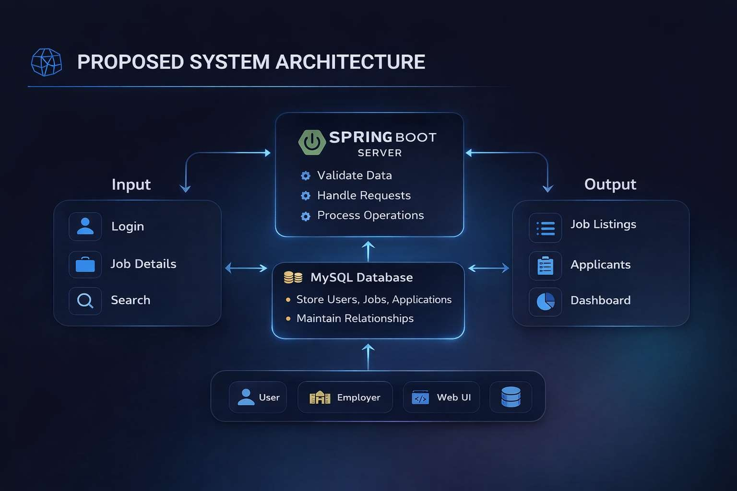
PROPOSED SYSTEM ARCHITECTURE
5
3
1
4
2
7
6
8
9

PROPOSED SYSTEM ARCHITECTURE
🔹 Input:
1
Users enter data such as login details, job search filters, and job postings. This data is collected through the web interface (frontend).
2
🔹 Processing:
3
The backend processes user requests and validates the input data.
4
It handles business logic like job posting, searching, and applications.
🔹 Database:
5
Stores all system data including users, jobs, and applications. Maintains relationships and ensures data consistency.
6
🔹 Output:
7
Displays results such as job listings, dashboards, and application status. Provides real-time responses to users based on their actions.
8
🔹 Data Flow:
9
Data flows from user input → backend processing → database → output display. Ensures smooth communication between all system components.

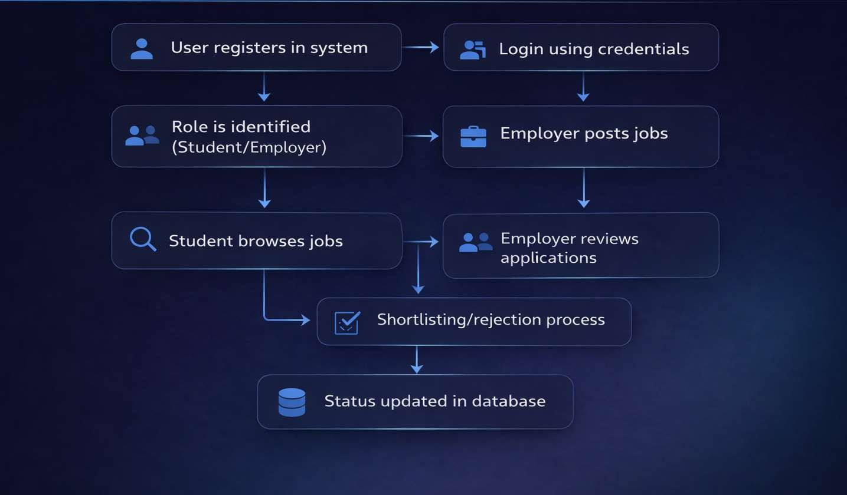
WORKFLOW
6
3
1
4
2
7
5
8
9

TECHNOLOGIES USED

Frontend: HTML, CSS, JavaScript Backend: Java, Node.js (Express.js) Database: MySQL
3
1
4
2
Security: Spring Security
5
Tools: Visual Studio Code, Maven
7
6
Hardware/Software Requirements: Minimum 4GB RAM, JDK 17+, Web Browser
8
9

MODULE DESCRIPTION

Module 1: User Authentication:
1
- Secure login and registration
2
- Handles secure login by verifying username and password
3
- Role-based access (Student / Employer / Admin)

Module 2: Job Management:
4
- Employers can post, edit, delete jobs
5

Module 3: Application Management:
6
- Students apply for jobs, Track application status Module 4: Search & Filter:
7
Filter jobs by:
8
- Location
- Skills
- Experience
9

IMPLEMENTATION SCREENSHOTS
8
3
4
6
5
7
9
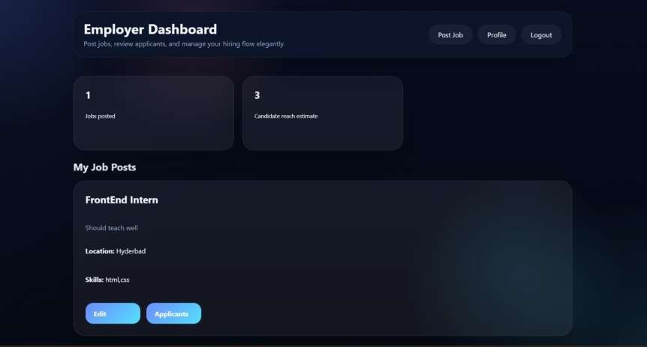
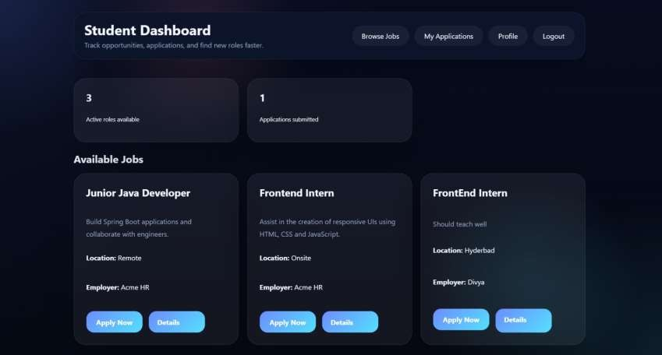
Main Module:
1
2

Loge Page:

IMPLEMENTATION SCREENSHOTS

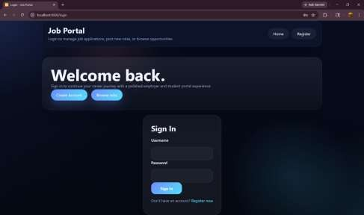
Secure authentication page for admin/user access.
3
1
2

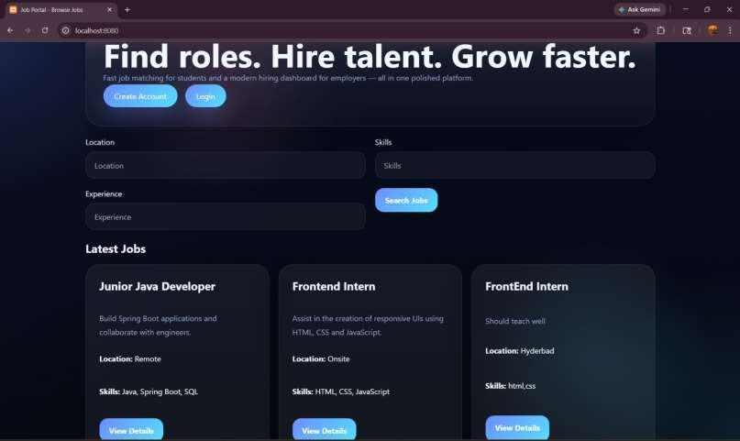
Finding job:
4
6
5

7
8(A)
9

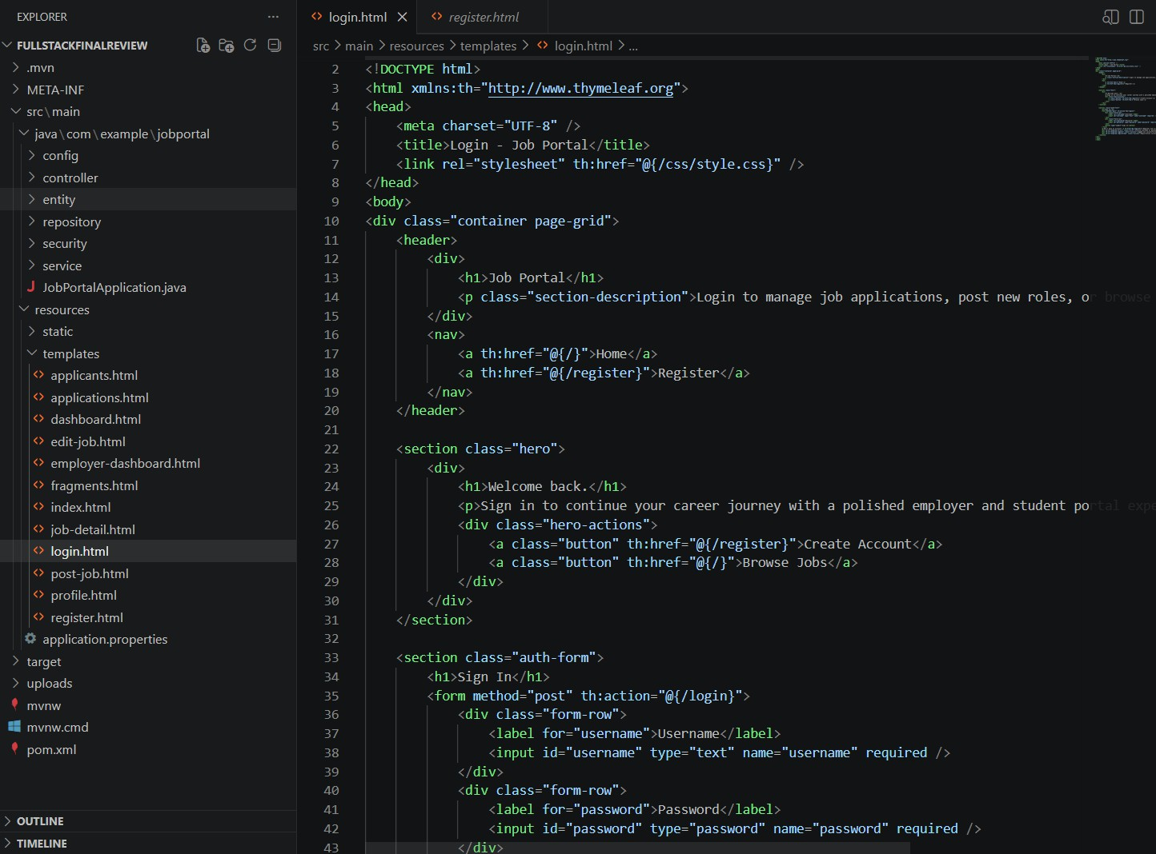
IMPLEMENTATION SCREENSHOTS
8(C)
3
1
4
2
6
5
7
9

ADVANTAGES & LIMITATIONS
ADVANTAGES:
1
- User-friendly interface
2
- Fast and efficient system
3
- Centralized data management
4
- Secure authentication
5
LIMITATIONS:
6
- Requires internet connection
7
- Basic features in current version
8
- No AI-based recommendations
9
- Limited scalability without cloud

Thank you

